Dataset
The dataset for demonstration purposes consists of the following fields.
Query (for last 30 days):-
a. Display top domains with maximum backup duration.

host=splunk sourcetype=csv backupduration=* domain=* | table _time backupduration domain
Save the query as a new dashboard. (Save as -> New Dashboard).
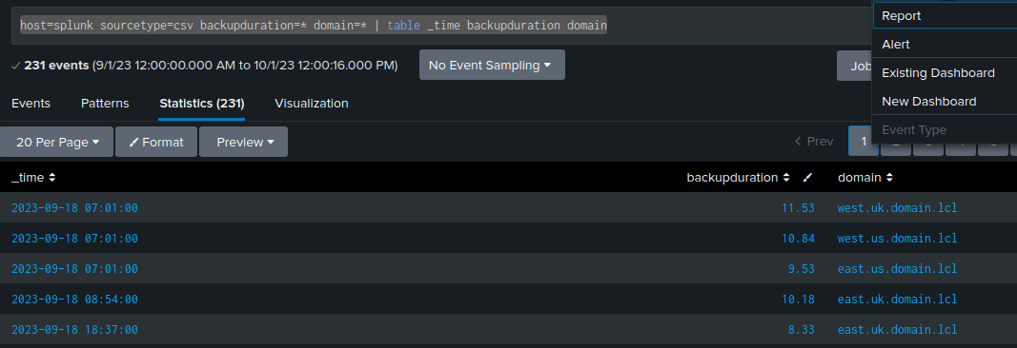
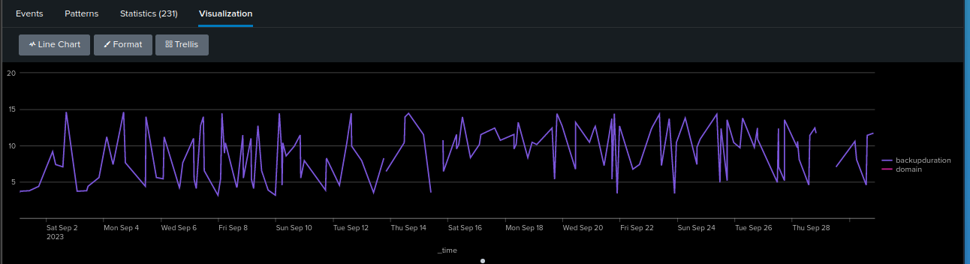
Select the chart of your choice. (The above dashboard show time (x-axis) vs backup duration (y-axis).

b. Average backup duration

host=splunk sourcetype=csv backupduration=* domain=* | stats avg(backupduration)
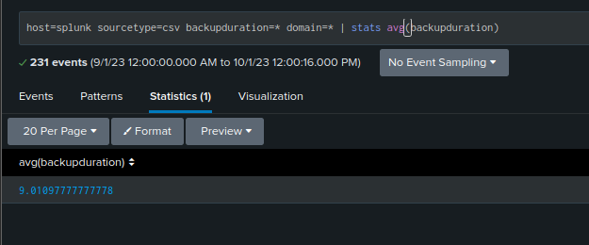
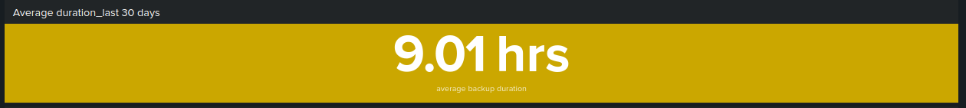

c. Maximum backup duration based on domain.

host=splunk sourcetype=csv backupduration=* domain=* | stats max(backupduration) by domain
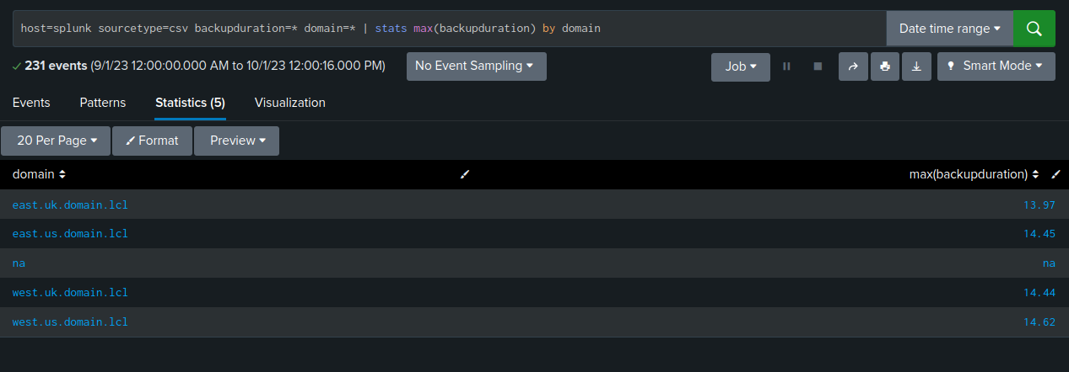
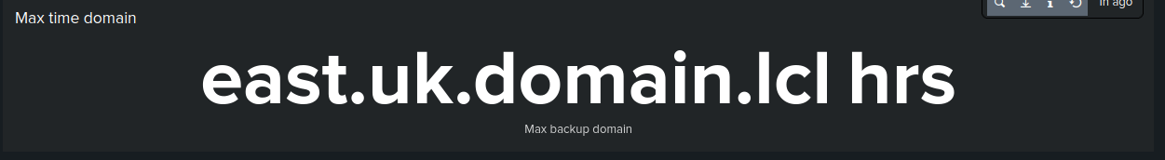
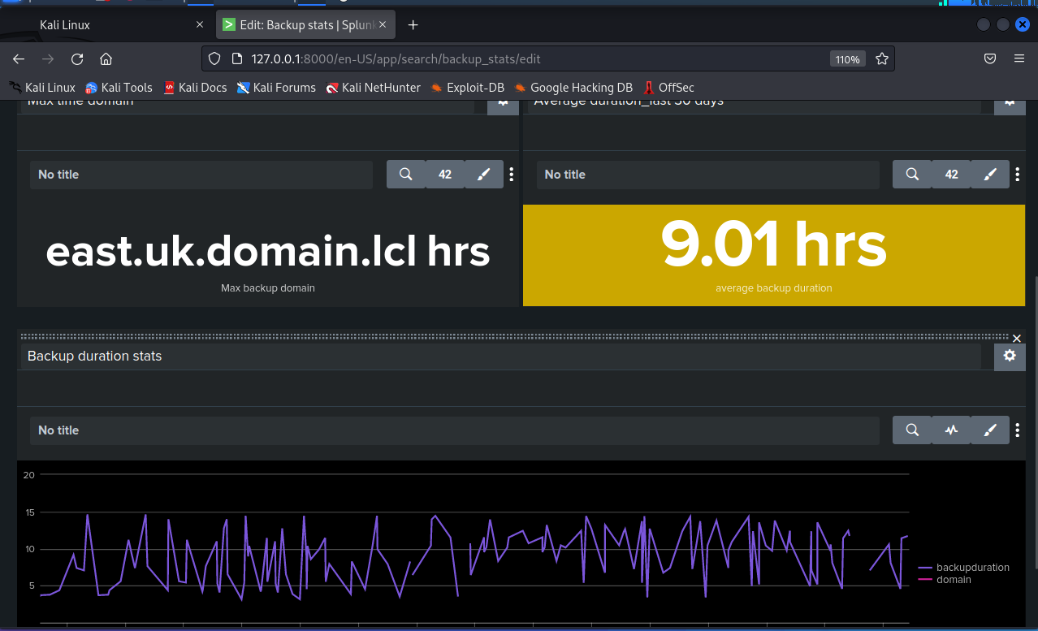

Time conversion functions

host="splunk" | eval newtime=strftime(_time, "%y %m-%d %I:%M%p") | table _time newtime
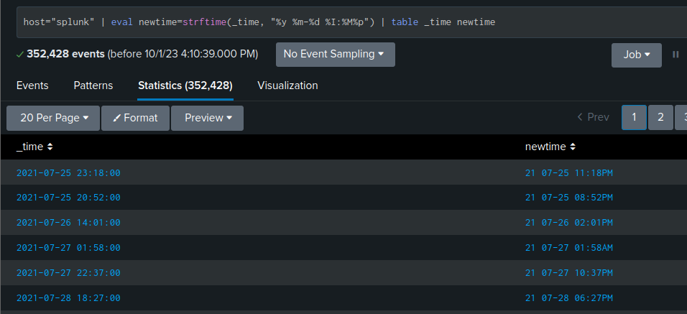
host="splunk" | eval newtime=strftime(_time, "%Y %m-%d %I:%M%p") | table _time newtime
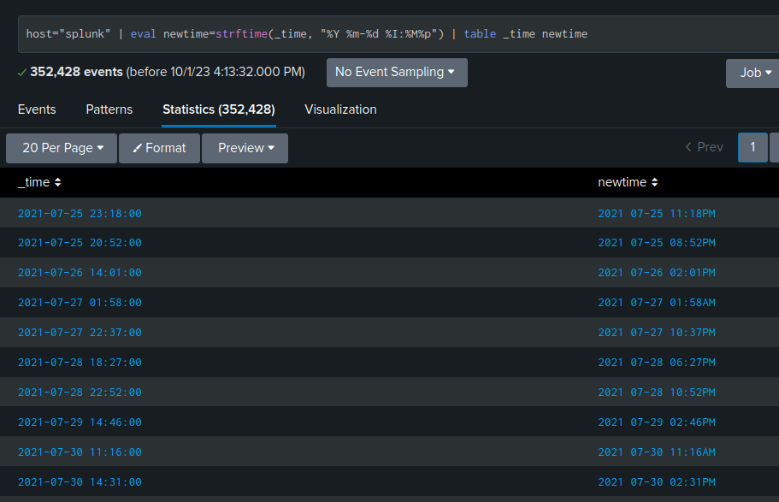

Internal index of splunk and extracting new fields

index=_internal
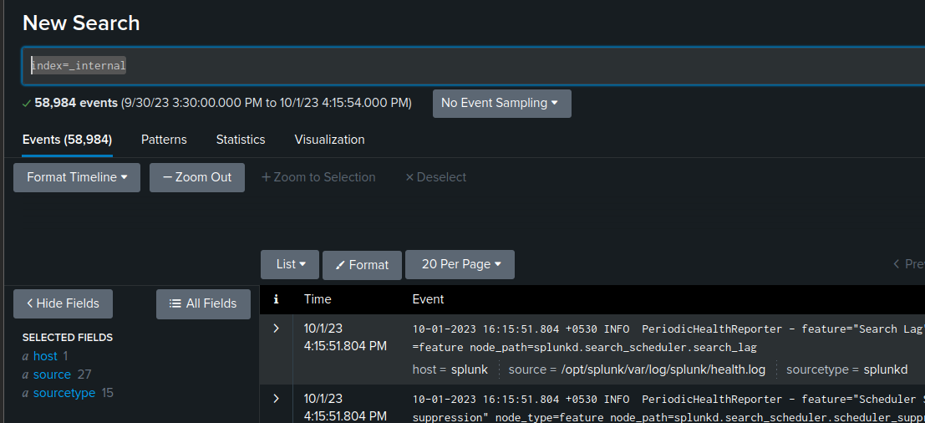
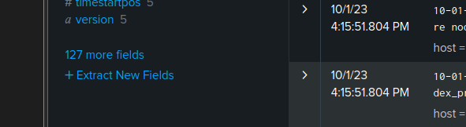

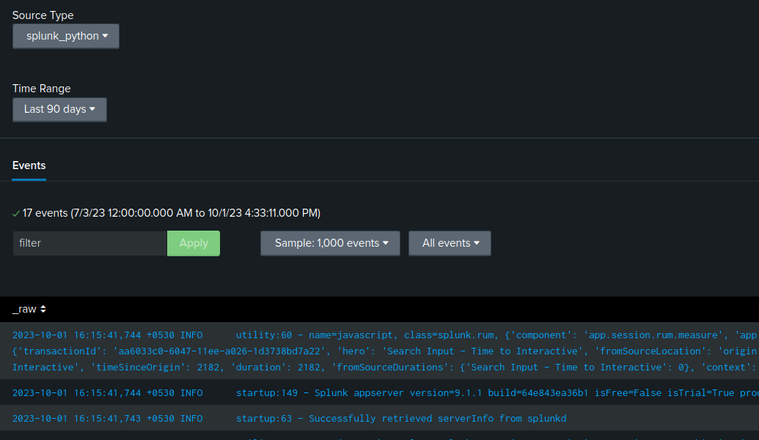
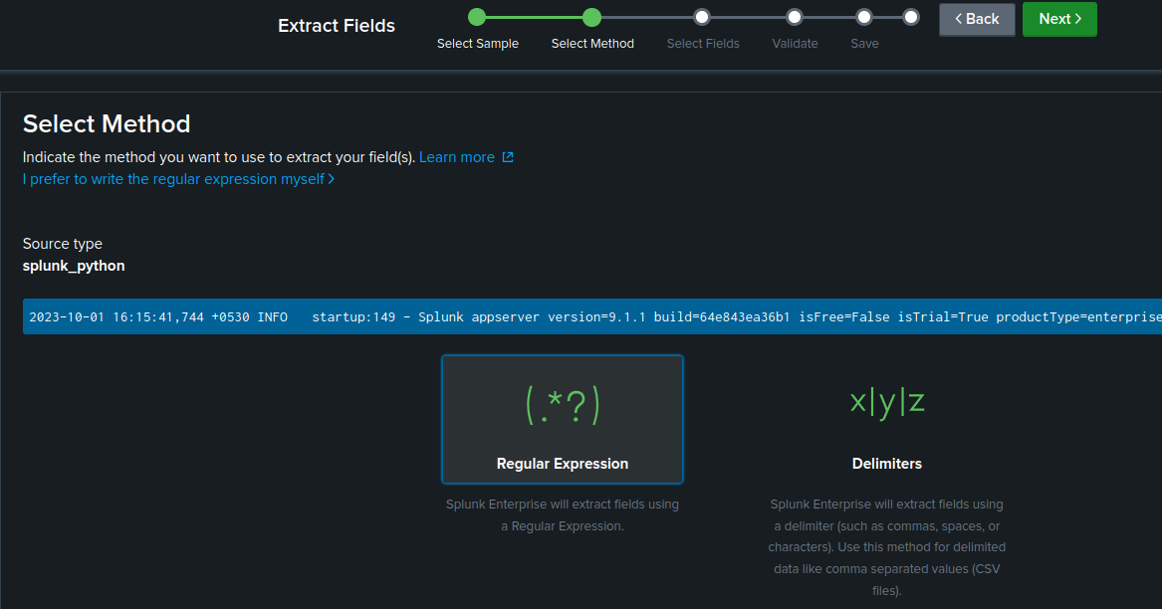
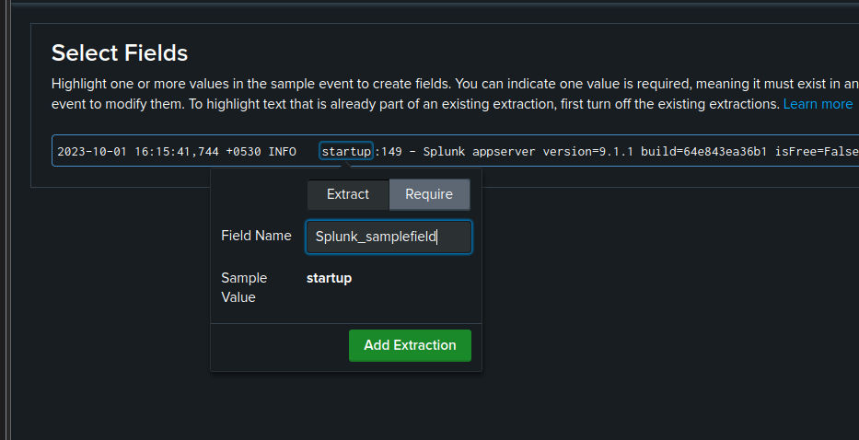
Adding new filed and naming the value startup as Splunk_samplefield

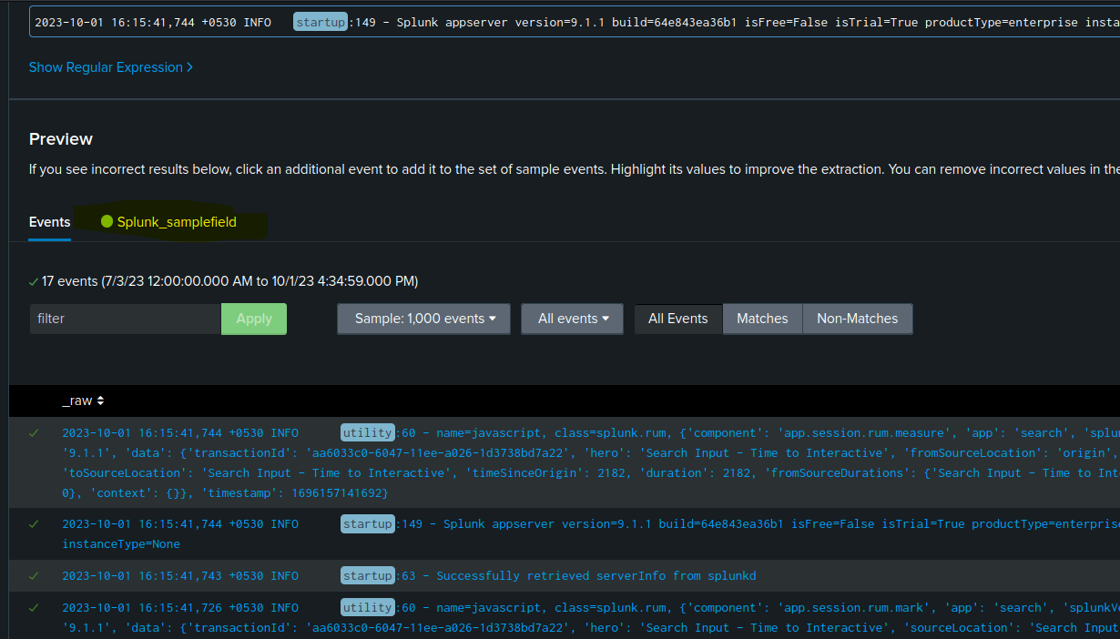
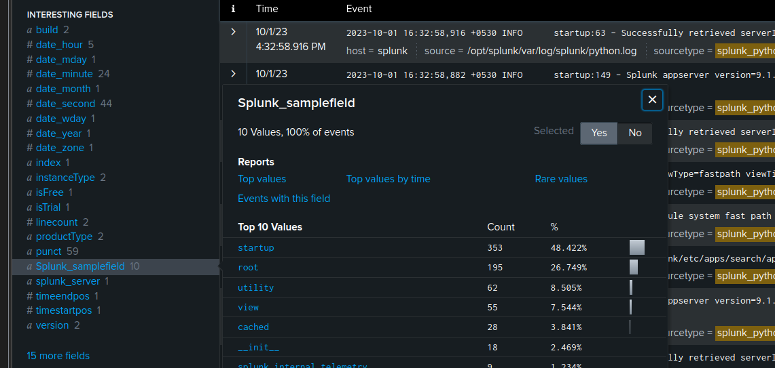

In the screenshot we can see the new filed is added as part of existing list of fields.
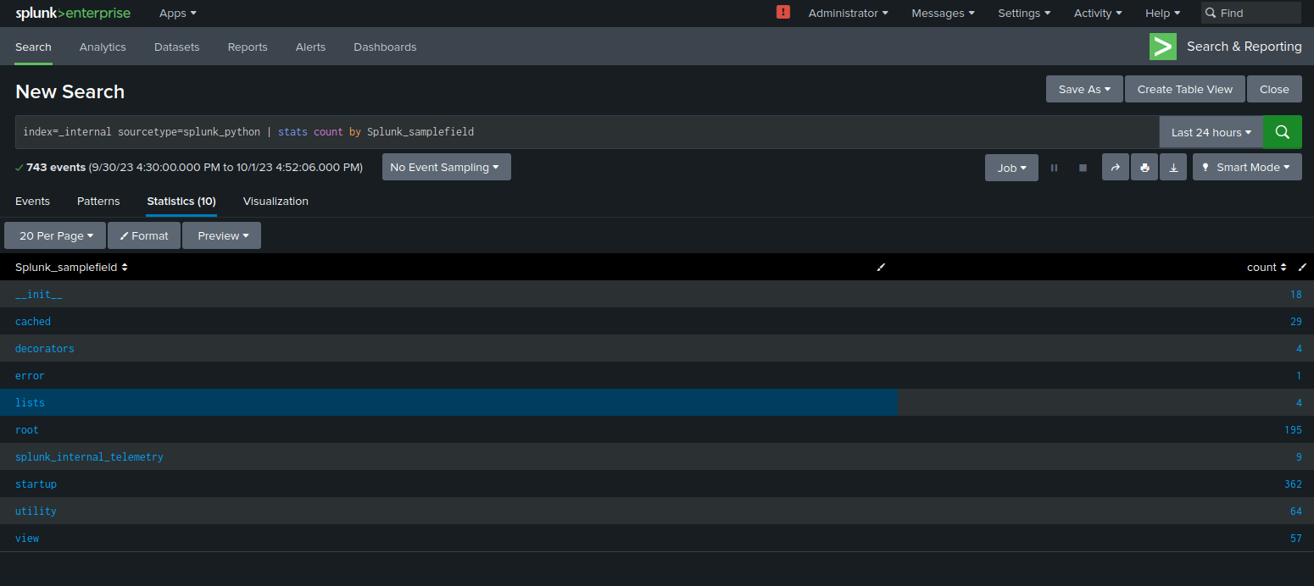
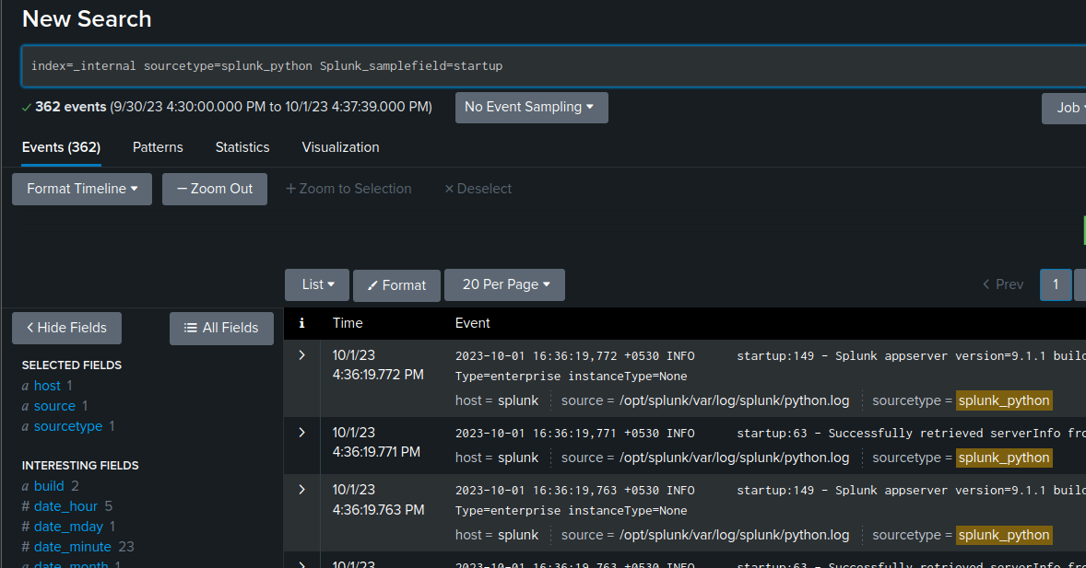
Naming fields and sorting data
index=_internal sourcetype=splunk_python | stats count as event_count by Splunk_samplefield | sort -event_count
